Pavel Arseniev
Reported Speech

This is the first bi-lingual English-Russian edition of Pavel Arseniev’s poetry. Arseniev is a St. Petersburg writer, editor, political activist, theoretician, and recipient of the Andrei Bely prize, Russia’s most prestigious literary award. The book contains an introduction by Kevin M.F. Platt (University of Pennsylvania) and is edited by Anastasiya Osipova.
Arseniev’s poetry provides a living link between the legacy of the 1920s Soviet avant-garde art and theory, on the one hand, and the modern Western materialist thought on the other. It traces how these diverse influences become weaponized in the language of contemporary Russian protest culture. Arseniev readily politicizes all, even the most mundane facts of the poet’s life, while at the same time, approaching reified bits of found speech and propaganda with lithe, at times corrosive irony and lyricism.
“One hundred years after the October revolution, LEF (Left Front of the Arts), and Russian Formalism, Pavel Arseniev brings into Russian poetry the militant excitement of subversive materialist exploration and canny activist protest. The unique results of this poetic event will, without a doubt, be exceptionally interesting and useful to an American reader.”
Kirill Medvedev, the author of It’s No Good

“Pavel Arseniev charts the ‘emergence of unexpected forms of collective life...’ These vivid translations show contemporary Russian poetry at one of its high points, where language laughs at its own seriousness but opens the way for astute cultural insights and a bracing evocation of life lived out loud.”
Stephanie Sandler, Harvard University

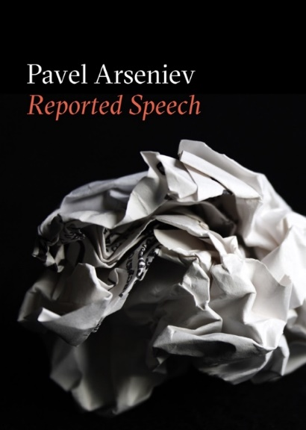

Trade Paperback
Poetry // $16
5 x 7 in. // 204 pp.
ISBN 978-0-9910420-4-3
Small Press Distribution

Release Date: November 30, 2018

Pavel Arseniev (b. 1986) is a Russian artist, poet and theoretician. He is also known for editing and galvanizing intellectual forces around the St. Petersburg-based journal of poetics and theory, Translit – an activity for which he received an Andrei Bely prize, Russia’s most prestigious literary award – and for inventing the slogan that became a rallying cry of the 2012 anti-Putin protests. His poems have been translated into English, Italian, Danish, Dutch, Bulgarian, Polish and Slovenian.

